Name:- Dipti kumari

Coding Challenge:- PetPals, The Pet Adoption Platform

Github Repository:-

Tasks:

1. Provide a SQL script that initializes the database for the Pet Adoption Platform ”PetPals”.

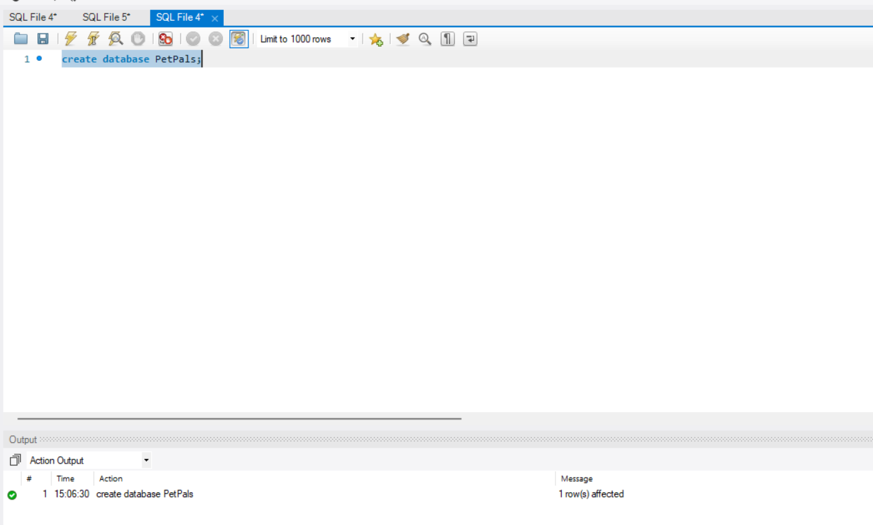

1. Create tables for pets, shelters, donations, adoption events, and participants.

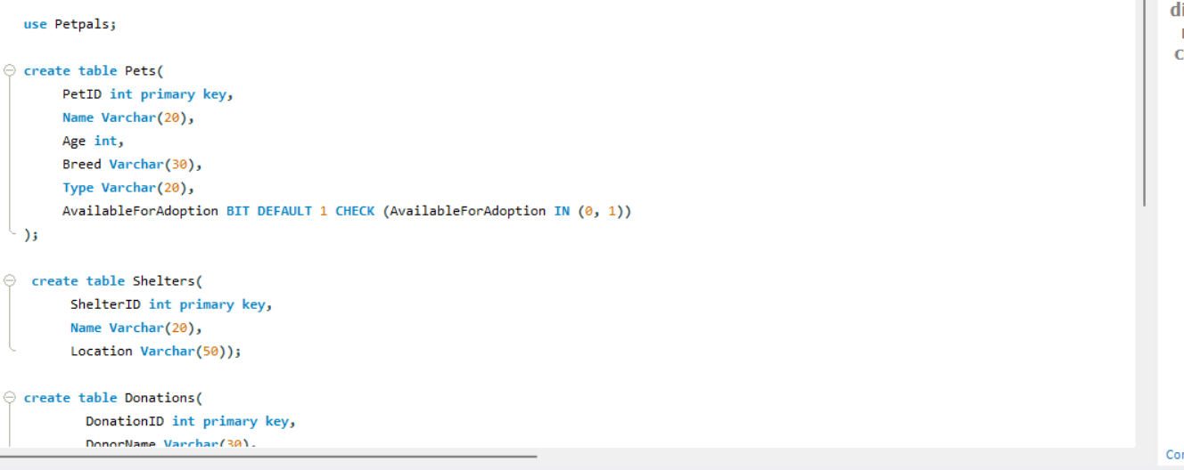

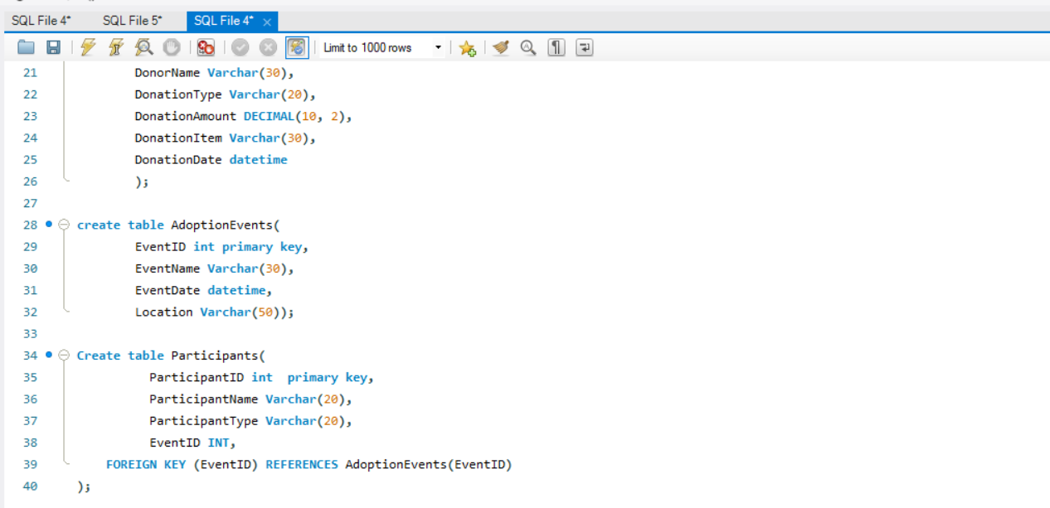

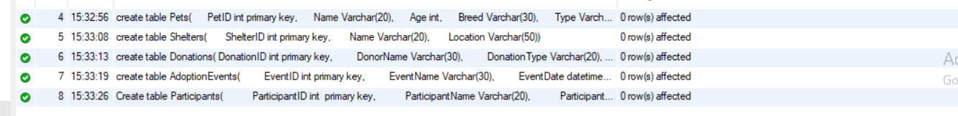

1. Define appropriate primary keys, foreign keys, and constraints. 





1. Ensure the script handles potential errors, such as if the database or tables already exist.







SQL:-

create database PetPals;

use Petpals;

create table Pets(

PetID int primary key,

Name Varchar(20),

Age int,

Breed Varchar(30),

Type Varchar(20),

AvailableForAdoption BIT DEFAULT 1 CHECK (AvailableForAdoption IN (0, 1))

);

create table Shelters(

ShelterID int primary key,

Name Varchar(20),

Location Varchar(50));

create table Donations(

DonationID int primary key,

DonorName Varchar(30),

DonationType Varchar(20),

DonationAmount DECIMAL(10, 2),

DonationItem Varchar(30),

DonationDate datetime

);

create table AdoptionEvents(

EventID int primary key,

EventName Varchar(30),

EventDate datetime,

Location Varchar(50));

Create table Participants(

ParticipantID int primary key,

ParticipantName Varchar(20),

ParticipantType Varchar(20),

EventID INT,

FOREIGN KEY (EventID) REFERENCES AdoptionEvents(EventID)

);

insert into pets values(101, 'Buddy',8,'Bulldog','Dog',0);

insert into pets values(102, 'Bella',6,'Chow Chow','Dog',0);

insert into pets values(103, 'Max',10,'German Shepherd','Dog',1);

insert into pets values(104, 'Daisy',7,'Poodle','Dog',1);

insert into pets values(105, 'Copper',9,'Siberian Husky','Dog',1);

insert into pets values(106,'Milo', 13, 'British Shorthair','Cat',0);

insert into pets values(107,'Teddy',15,'Himalayan Cat','Cat', 1);

insert into pets values(108,'Bella', 14,'American Shorthair','Cat',1);

insert into pets values(109,'Mau',16,'Persian Cat','Cat',1);

insert into pets values(110,'Lucy',17,'British Shorthair','Cat',1);

insert into Shelters values(1,'Happy Paws', '123 Main Street, Springfield');

insert into Shelters values (2, 'Paw Haven', '456 Oak Avenue, Riverdale');

insert into Shelters values(3, 'Furry Friends', '789 Pine Street, Hilltown');

insert into Shelters values(4, 'Safe Tails', '321 Maple Road, Lakeside');

insert into Shelters values(5, 'Rescue Ridge', '654 Elm Blvd, Greenwood');

insert into Shelters values(6, 'Pet Nest', '987 Cedar Lane, Brookfield');

insert into Shelters values(7, 'Whisker World', '135 Birch Ave, Meadowville');

insert into Shelters values(9, 'Adoptopia', '369 Walnut Street, Parkview');

insert into Shelters values(10, 'Hope Paws', '159 Willow Way, Rosewood');

insert into Shelters values(8, 'Tail Town', '246 Spruce Dr, Stonebridge');

INSERT INTO Donations VALUES (1, 'Karan', 'Cash', 100.00, NULL, '2025-04-01 10:30:00');

INSERT INTO Donations VALUES (2, 'Ram', 'Item', NULL, 'Dog Food', '2025-04-02 14:15:00');

INSERT INTO Donations VALUES (3, 'Rita', 'Cash', 250.00, NULL, '2025-04-03 09:00:00');

INSERT INTO Donations VALUES (4, 'Mohan', 'Item', NULL, 'Cat Toys', '2025-04-03 11:45:00');

INSERT INTO Donations VALUES (5, 'Sita', 'Cash', 50.00, NULL, '2025-04-04 13:20:00');

INSERT INTO Donations VALUES (6, 'Rahul', 'Item', NULL, 'Leashes', '2025-04-05 15:10:00');

INSERT INTO Donations VALUES (7, 'Simarn', 'Cash', 175.00, NULL, '2025-04-06 16:30:00');

INSERT INTO Donations VALUES (8, 'Krish', 'Item', NULL, 'Blankets', '2025-04-06 17:45:00');

INSERT INTO Donations VALUES (9, 'Anjali', 'Cash', 80.00, NULL, '2025-04-07 10:05:00');

INSERT INTO Donations VALUES (10, 'Shruti', 'Item', NULL, 'Pet Beds', '2025-04-08 09:40:00');

INSERT INTO AdoptionEvents VALUES (1011, 'Spring Adopt Fest', '2025-03-21 10:00:00', 'Central Park');

INSERT INTO AdoptionEvents VALUES (2021, 'Paws & Hearts Day', '2025-02-14 11:00:00', 'City Hall Grounds');

INSERT INTO AdoptionEvents VALUES (3011, 'Furry Friends Fair', '2025-04-12 09:30:00', 'Lakeside Community Center');

INSERT INTO AdoptionEvents VALUES (4021, 'Adoptathon 2025', '2025-05-01 12:00:00', 'Greenfield Shelter');

INSERT INTO AdoptionEvents VALUES (5011, 'Tail Wagging Weekend', '2025-06-15 13:30:00', 'Meadow Park');

INSERT INTO AdoptionEvents VALUES (6021, 'Pet Palooza', '2025-07-20 10:00:00', 'Sunshine Mall');

INSERT INTO AdoptionEvents VALUES (7011, 'Hearts for Paws', '2025-08-10 14:00:00', 'Downtown Plaza');

INSERT INTO AdoptionEvents VALUES (8021, 'Home for Every Paw', '2025-09-25 15:45:00', 'Riverside Shelter');

INSERT INTO AdoptionEvents VALUES (9011, 'Fall Fur Fest', '2025-10-18 11:30:00', 'Hillside Community Hall');

INSERT INTO AdoptionEvents VALUES (10211, 'Winter Woofs', '2025-12-10 13:00:00', 'Snowfall Park');

INSERT INTO Participants VALUES (1, 'Aarav Patel', 'Adopter', 1011);

INSERT INTO Participants VALUES (2, 'Seema Verma', 'Adopter', 2021);

INSERT INTO Participants VALUES (3, 'Happy Paws', 'Shelter', 3011);

INSERT INTO Participants VALUES (4, 'Nisha Sharma', 'Adopter', 4021);

INSERT INTO Participants VALUES (5, 'Stray Love', 'Shelter', 5011);

INSERT INTO Participants VALUES (6, 'Rohan Mehra', 'Adopter', 6021);

INSERT INTO Participants VALUES (7, 'PawCare India', 'Shelter', 7011);

INSERT INTO Participants VALUES (8, 'Meera Iyer', 'Adopter', 8021);

INSERT INTO Participants VALUES (9, 'PetNest Delhi', 'Shelter', 9011);

INSERT INTO Participants VALUES (10, 'Amit Joshi', 'Adopter', 10211);

Select \* from pets;

Select \* from Shelters;

Select \* from Donations;

Select \* from AdoptionEvents;

Select \* from Participants;

1. Write an SQL query that retrieves a list of available pets (those marked as available for adoption) from the "Pets" table. Include the pet's name, age, breed, and type in the result set. Ensure that the query filters out pets that are not available for adoption.

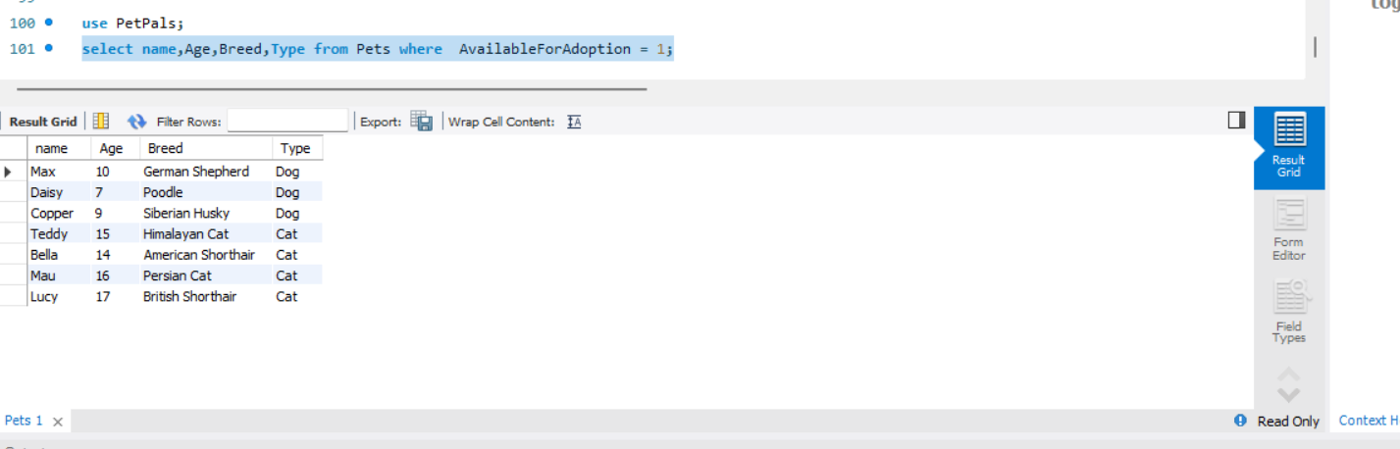

1. Write an SQL query that retrieves the names of participants (shelters and adopters) registered for a specific adoption event. Use a parameter to specify the event ID. Ensure that the query joins the necessary tables to retrieve the participant names and types.

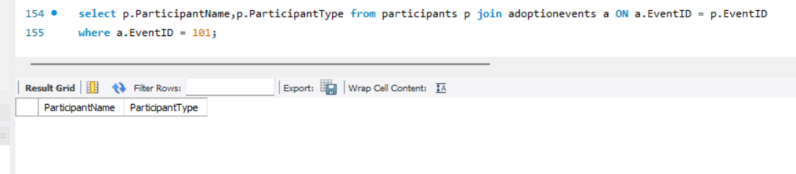

1. Create a stored procedure in SQL that allows a shelter to update its information (name and location) in the "Shelters" table. Use parameters to pass the shelter ID and the new information. Ensure that the procedure performs the update and handles potential errors, such as an invalid shelter ID.

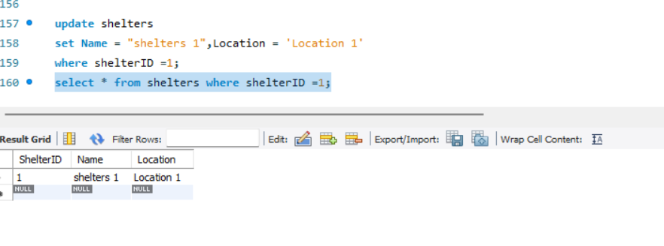

1. Write an SQL query that calculates and retrieves the total donation amount for each shelter (by shelter name) from the "Donations" table. The result should include the shelter name and the total donation amount. Ensure that the query handles cases where a shelter has received no donations.

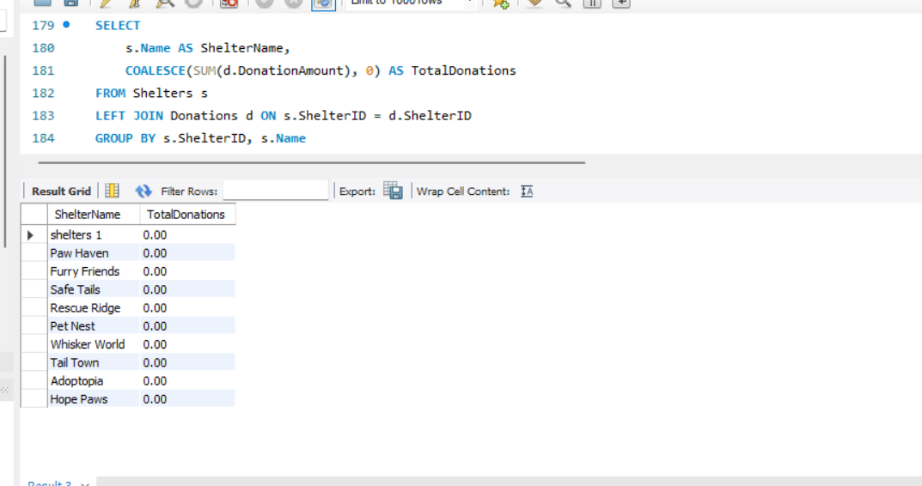

1. Write an SQL query that retrieves the names of pets from the "Pets" table that do not have an owner (i.e., where "OwnerID" is null). Include the pet's name, age, breed, and type in the result set.

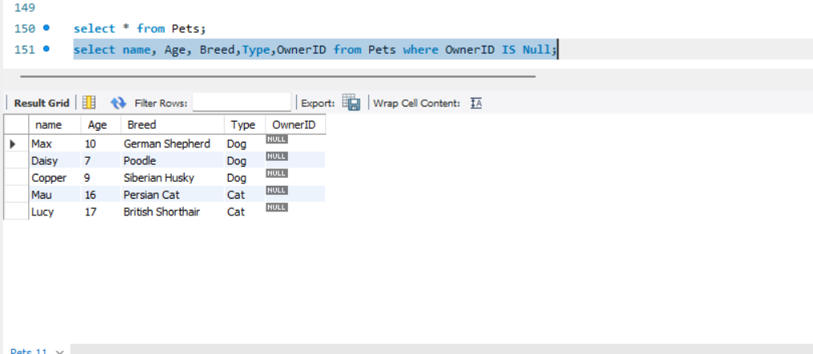

1. Write an SQL query that retrieves the total donation amount for each month and year (e.g., January 2023) from the "Donations" table. The result should include the month-year and the corresponding total donation amount. Ensure that the query handles cases where no donations were made in a specific month-year.

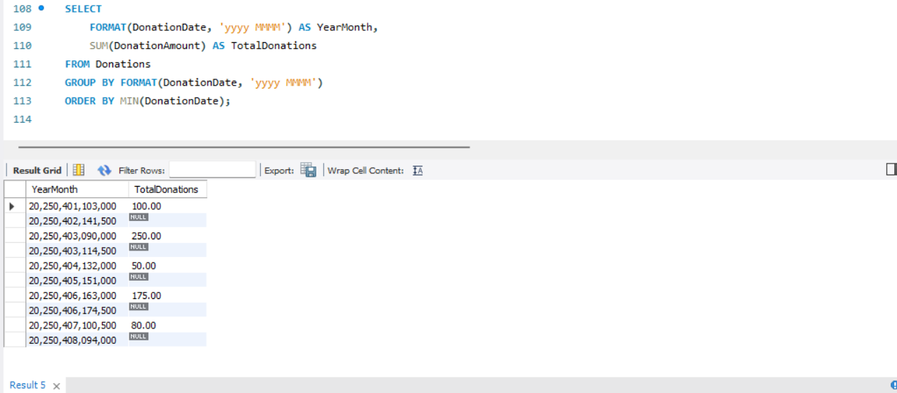

11.Retrieve a list of distinct breeds for all pets that are either aged between 6 and 9 years or older than 10 years.

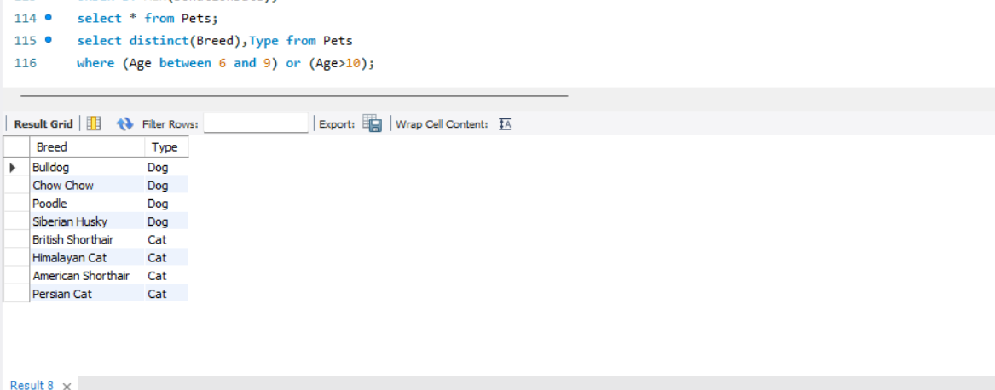

12.Retrieve a list of pets and their respective shelters where the pets are currently available for adoption.

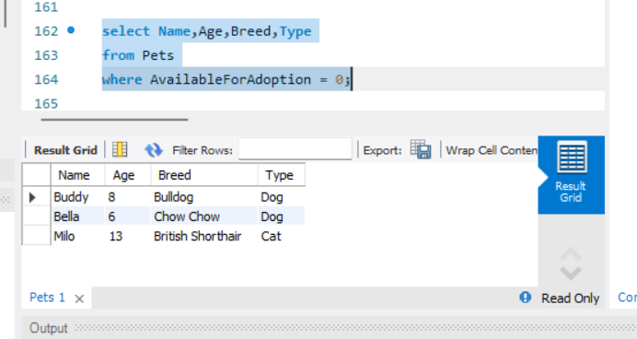

13. Find the total number of participants in events organized by shelters located in specific city. Example: City=Chennai

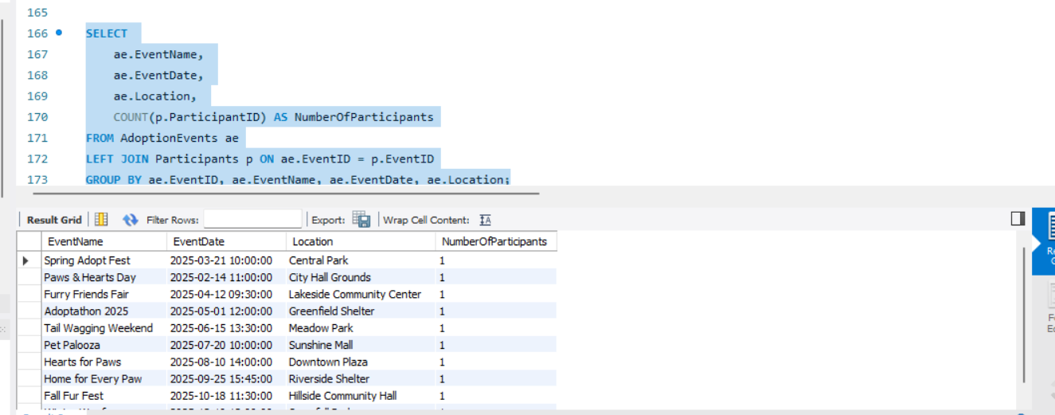

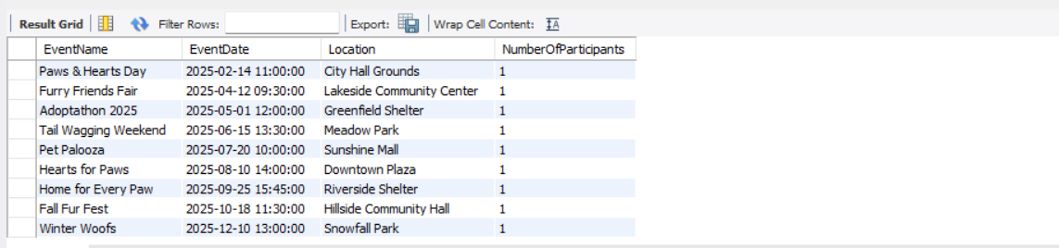

14. Retrieve a list of unique breeds for pets with ages between 6 and 10 years.

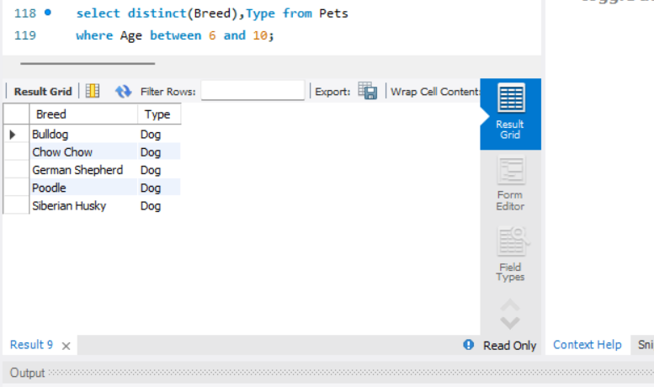

15. Find the pets that have not been adopted by selecting their information from the 'Pet' table.

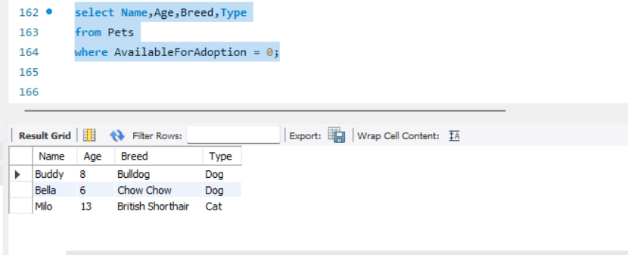

16. Retrieve the names of all adopted pets along with the adopter's name from the 'Adoption' and 'User' tables.

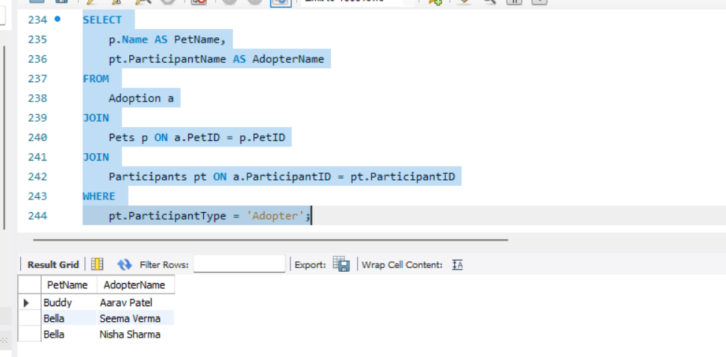

17. Retrieve a list of all shelters along with the count of pets currently available for adoption in each shelter.

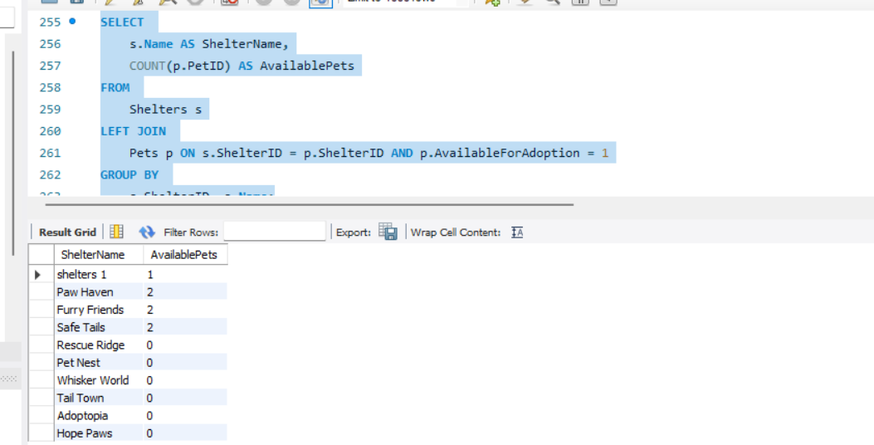

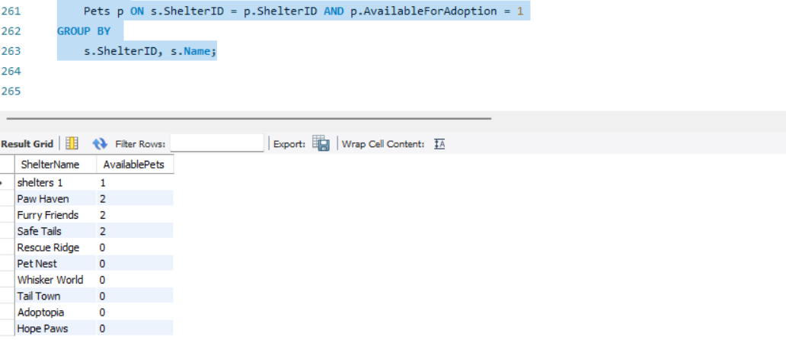

18. Find pairs of pets from the same shelter that have the same breed.

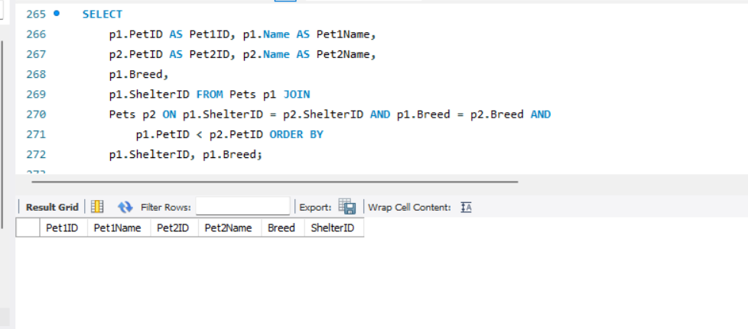

19. List all possible combinations of shelters and adoption events.

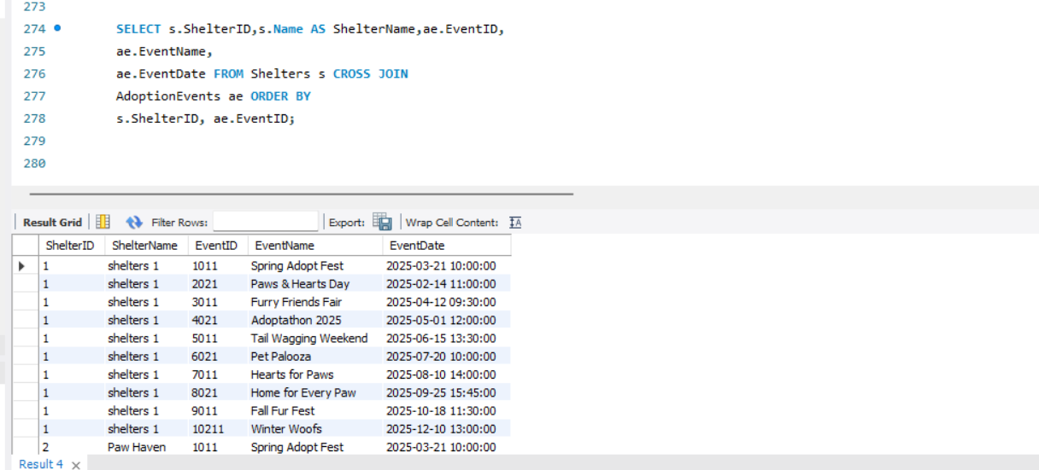

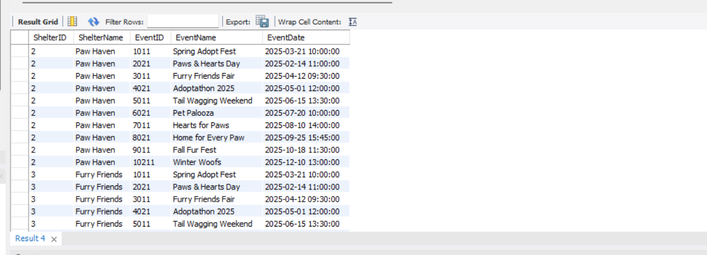

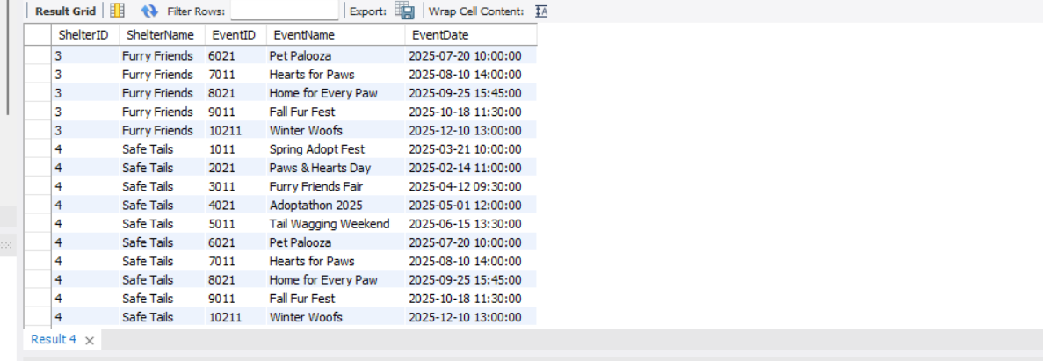

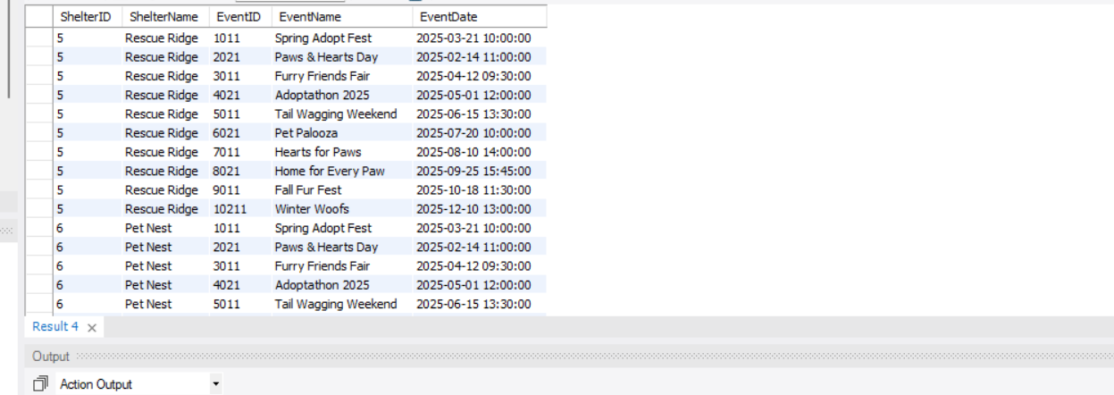

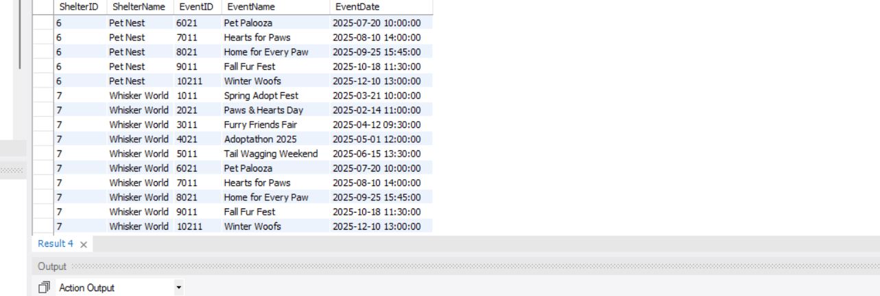

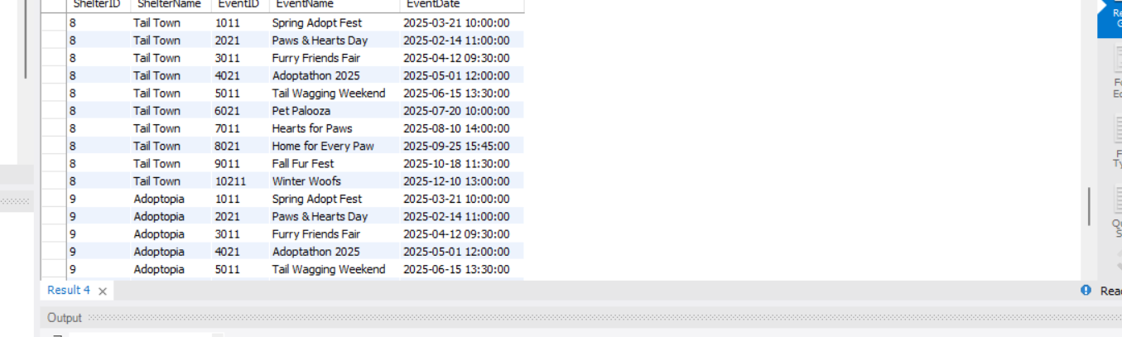

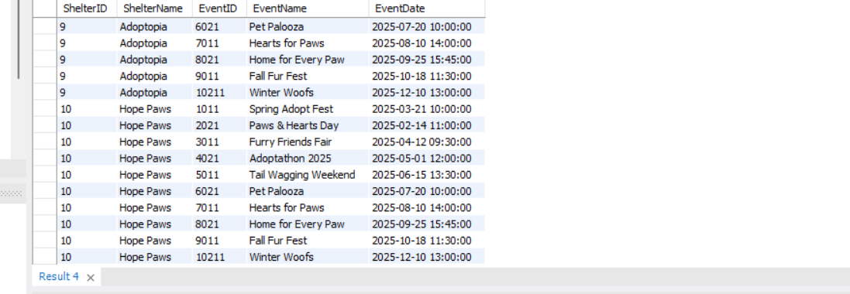

20. Determine the shelter that has the highest number of adopted pets.

